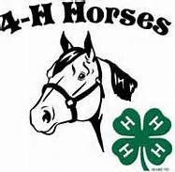 Reasons Sheet

Class 1:_________________________________

Horse 1: ______________________
Color and Markings: ___________________

Good: Bad:

Horse 2:___________________________________

Good: Bad:

Horse 3: ___________________________

Good: Bad:

Horse 4: ___________________________

Good: Bad:

